**Website Template version: 1.0.0**

PuzzlesCloud Website

Think Green. No paper prints anymore!

Online Documentation

**PuzzlesCloud d.o.o**

**https://puzzlescloud.com**

**Document ID00001**

**1.2.0**

**Release Date: 15.06.2022**

Intellectual Property Rights

This document is exclusive property of PuzzlesCloud.com and its content is published documentation of the docs website: <https://puzzlescloud.com/docs/>.

Table of Contents

1 About Us 5

1.1 Who We Are 5

1.2 Our Vision 5

1.2.1.1.1 DevOps Software vs Docs Steps 6

1.3 Our Mission 7

2 docs 8

2.1 Welcome to Docs 8

2.2 integrations 8

2.2.1 Integrations with Others 8

2.2.1.1 OAuth Providers 8

2.2.1.2 Git Repos Import & Push 9

2.2.1.3 Webhook Support 9

2.2.1.4 Docs Publishing Support 9

2.3 getting-started 9

2.3.1 Getting Started 9

2.3.2 1. Create Professional DOCX Template 9

2.3.3 2. Import Your Git Repository 11

2.3.4 3. Create a New Doc 13

2.3.5 Publish Created Doc 17

2.3.6 Configure Webhook 18

2.3.7 Add PDF/DOCX Download to your Jekyll Website 20

2.4 use-cases 22

2.4.1 Use Cases 22

2.4.2 Enable docx-as-code for your DevOps/Agile Team 22

2.4.3 Convert your Static Website to PDF 22

2.4.4 Publish Docs Without Pain 24

2.5 faq 26

2.5.1 How to migrate Confluence data to Git based Wiki? 26

2.5.2 What's the difference between Confluence & PuzzlesCloud? 26

2.5.3 What are docs-as-code typical doc types? 26

2.5.3.1 Technical Documentation in Software Development 26

2.5.4 How to setup Git branches and approval workflow? 27

2.5.5 How to convert existing docx files into MarkDown? 28

2.5.6 How to setup Git repo to prevent undesired pushes? 28

2.5.6.1 Protected Branches 29

2.5.6.2 Push Rules 29

2.5.7 FAQ 29

2.5.8 Where is your SaaS hosted? 29

2.5.9 How to leverage Wiki pages for docx-as-code? 29

2.6 policies 30

2.6.1 Policies 30

2.6.2 Privacy Policy 30

2.6.2.1 Data Types and Collection Methods 30

2.6.2.2 Data Collection Purpose and Data Usage 30

2.6.2.3 Data Transfer and Links to Third Parties 31

2.6.2.4 Legal and Other Disclosures 31

2.6.2.5 Security 31

2.6.2.6 Changes to Our Privacy Policy 32

2.6.2.7 Contact 33

2.6.3 Terms and Conditions 33

3 blog 39

3.1 How to Maximize Content Reuse of Tech Documentation? 39

3.1.1 Static Site Generators 39

3.1.2 Wiki Content 39

3.1.3 Native MarkDown Content 40

3.1.4 Our Recommended Approach 40

3.2 How Customer Success Engineer can benefit from docx-as-code? 40

3.2.1 What is the role of Customer Success Engineer? 41

3.2.2 How can a Customer Success Engineer achieve more with less? 41

3.3 Raising Starts Program Finalists 42

3.3.1 Partnership with Raising Starts Program 42

3.4 StarTech Program Winners 42

3.4.1 About StarTech Program 43

3.5 Why docs-as-code? 43

3.5.1 Introduction 43

3.5.2 Docs-as-code for Online Docs and Blogs 43

3.5.3 Docx-as-code for Offline Docs 44

3.5.4 Benefits of docs-as-code using Git 45

3.5.5 Conclusion 45

Table of Figures

Figure 1 DevOps Infinite Cycle 6

Figure 2 Interworking with others 8

Figure 3 Download Template 10

Figure 4 Upload Template 11

Figure 5 New repo 12

Figure 6 Add repo 12

Figure 7 Add docx-as-code 13

Figure 8 New docx-as-code 14

Figure 9 Create docx-as-code 15

Figure 10 Created docx-as-code 16

Figure 11 docx-as-code options 16

Figure 12 docx-as-code options 17

Figure 13 Publish docx-as-code 18

Figure 14 docx-as-code dashboard options 19

Figure 15 Configure Webhook 19

Figure 16 Convert your Static Website to PDF 24

Figure 17 Work in our Webapp and Publish Docs in Git 25

Figure 18 Git branches and approval workflow for docs-as-code 27

Figure 19 content-reuse 40

# About Us

## Who We Are

We are a team of professionals who have got bored with documentation tools that are not compatible with practices we adore: Agile and DevOps.

All projects that we have worked on had something in common: It was very difficult to have Document Version Control in Git and at the same time produce nice-looking, professional DOCX (MS Word) or PDF documents. For that purpose, we have used Pandoc´s Markdown to PDF conversion, however that is everything but a single click solution.

This is what triggered us to start the PuzzlesCloud project and simplify the life of many people facing the same issue.

Now, if you have the necessary content, you can produce high-quality documents with simple drag and drop in a couple of seconds. That way, content writing has been decoupled from documents output and release management, as well as from document design & look. With a simple DOCX template change, you can give old content a new fresh look.

## Our Vision

PuzzlesCloud is a Git-based SaaS solution natively supporting the DevOps cycle in the DOCS area.

Our vision is very simple: Consider documents as software, keep Git as a source of truth for Document Version Control, review and approval process, implement Document Automation and deliver professional output docs.

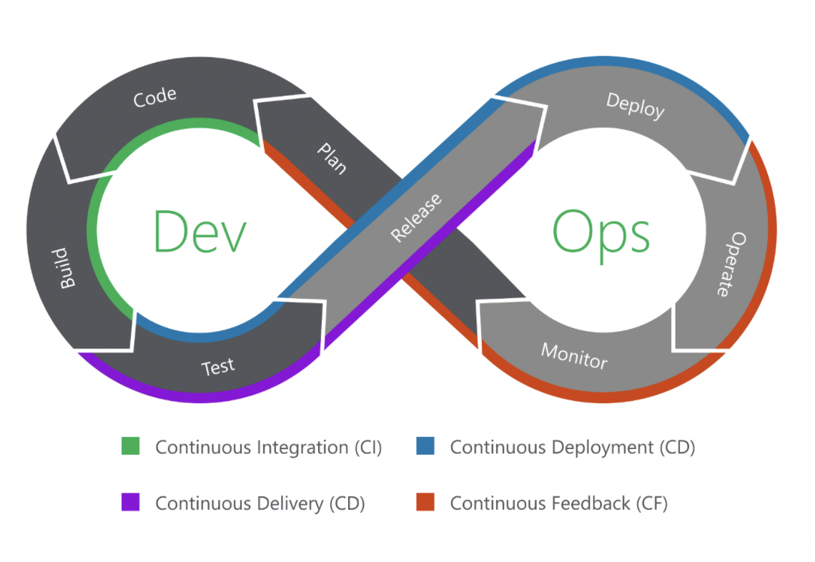

Figure 1 DevOps Infinite Cycle

If you are a DevOps fan, then this infinite DevOps cycle, presented above, with all stages involved should be more than familiar to you. From planning and creation, all the way to feedback stages, covering everything in the middle including testing, releases, and deployments can also be applicable to documentation. That way, you keep the same processes and workflows for software, as well as for documentation. You can also bring Docs Quality Assurance to the next higher level.

##### DevOps Software vs Docs Steps

| Software | docx-as-code pdf-as-code | PuzzlesCloud Step |
| --- | --- | --- |
| plan | plan | Plan Sprint. Create docx corporate templates (logo/styles/vars/look) |
| code | write | Write content in Git, or our WebApp |
| build | build | Webhook triggered Doc generation (docx or pdf) |
| test | test | Test Doc links, spelling, page brakes etc |
| release | release | Doc versioning and release management |
| deploy | share | Share Doc with a Client |
| operate | use | Client consumes the doc |
| monitor | comment | Client provides feedback |

## Our Mission

Our mission is very simple

To accelerate teams´ delivery worldwide.

There is no need to spend time on things that could be automated. The day is too short.

# docs

## Welcome to Docs

Here you can access complete documentation for PuzzlesCloud, explanation of the Use Cases covered, User Guides, Frequently Asked Questions and many more...

Download our docs website content as [.pdf](../../puzzlescloud/puzzlescloud.pdf) or [.docx](../../puzzlescloud/puzzlescloud.docx)

## integrations

### Integrations with Others

We do support integrations with other popular Webapps. Check out the details below.

On the following Figure, are outlined integration capabilities with the other Webapps:

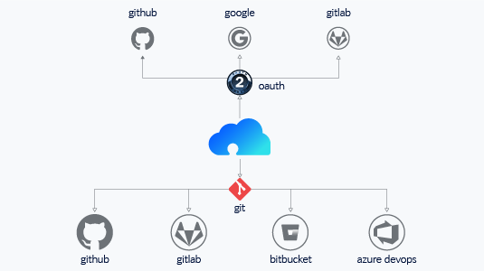

Figure 2 Interworking with others

#### OAuth Providers

We want your user experience on the top level. You don't need to remember many passwords any more. It is enough to register and login with one of the supported authentication providers.

Currently we support the following OAuth providers:

1. Google
2. GitLab
3. GitHub

#### Git Repos Import & Push

In order to import one of your projects to our Webapp or to push from our Webapp to Git repository, you would need to keep your cool projects in one of the supported Git service providers:

1. GitLab
2. GitHub
3. Azure DevOps
4. Atlassian (Bitbucket)

But no worries, we are working hard to support the others as well. Stay tuned.

#### Webhook Support

In order to automatically trigger the whole docx-as-code build cycle the following Webhook integrations are available

1. GitLab
2. GitHub

On how to configure the Webhook seervices, please check [this](../../docs/getting-started/webhook) article.

#### Docs Publishing Support

As of March 2022 it is possible to publish your documents to the following storage providers:

1. Google Drive

## getting-started

### Getting Started

In this section you'll find basic infos on how to start with our application. Have a fun!

Here are the articles in this section:

### 1. Create Professional DOCX Template

In this section we will explain the workflow on how to prepare DOCX template and upload to our Webapp. Initially, default DOCX templates can also be used.

The workflow is outlined below:

On the dashboard, select one of the default available templates. Click on the "..." button next to the template.

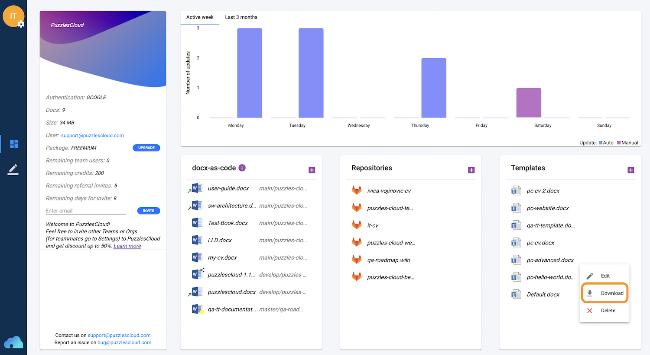

Figure 3 Download Template

Select the "Download" option.

Adjust the template according to your corporate standards (logo, styles, formatting etc). Please note that in order to be interoperable with PuzzlesCloud Webapp the following elements are required:

1. (mandatory) Document root label, which marks where the Webapp will start inserting the content. The label is the following text ###pc-toc-start### placed on desired place in the template.
2. (optional) Style names required to map 1:1 with MarkDown styles. If not set, our Webapp will, on template upload, set missing ones by default. The Styles names required are:
   1. PC_H1
   2. PC_H2
   3. PC_H3
   4. PC_H4
   5. PC_H5
   6. PC_H6
   7. PC_Normal
   8. PC_Bold
   9. PC_Italic
   10. PC_BlockCode
   11. PC_Code
   12. PC_BulletList
   13. PC_NumberedList
   14. PC_TaskList
   15. PC_Link
   16. PC_TableText
   17. PC_TableCaption
   18. PC_FigureCaption
3. (optional) Template Variables placed anywhere in the document with the following format PuzzlesCloud Website which can be filled out thorugh the application GUI and saved by the application.

Prepared DOCX template can be uploaded by clicking on the Templates "+" button circled by orange line.

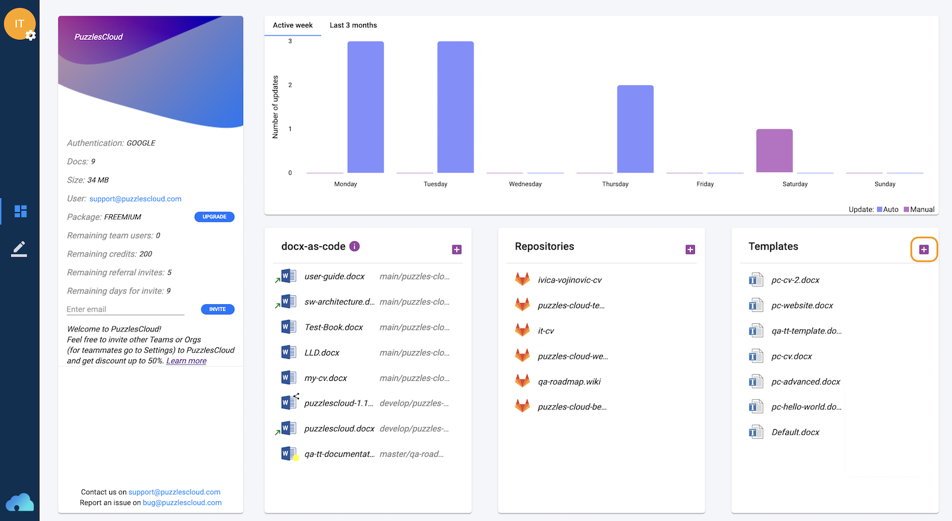

Figure 4 Upload Template

### 2. Import Your Git Repository

In this section we will explain the workflow on how to import a Git docs (e.g Wiki) or Website repo to our Webapp.

NOTE: Imported Git Repository and its content will be visible and accessible to your teammates (Webapp tenant).

The workflow is outlined below:

On the dashboard, click on the Repositories "+" button circled by orange line.

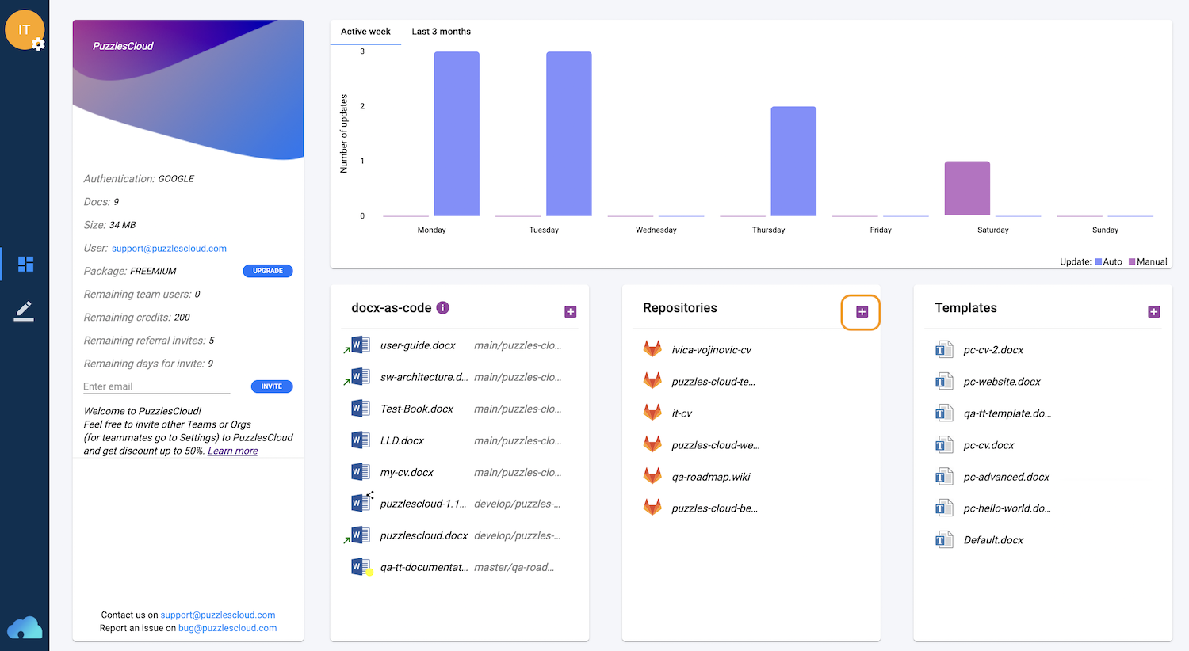

Figure 5 New repo

It will open up the following window, where you should add mandatory fields:

* "URL" (HTTPS clone URL of your Git Repository)
* "Token" (If Git Repository is public, you can add random text here)

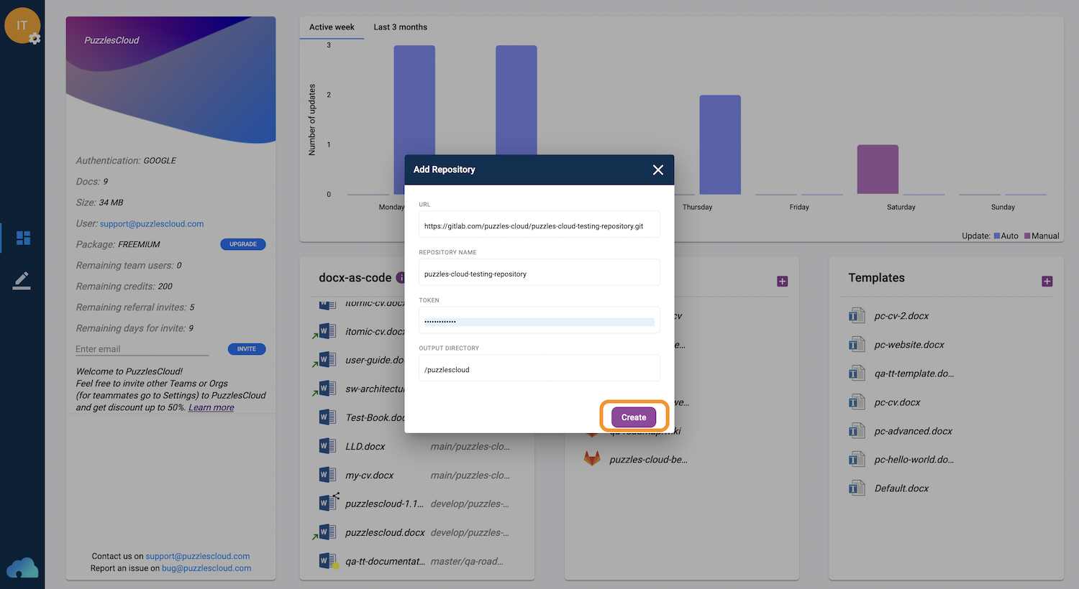

Figure 6 Add repo

Details on how to create access token:

* [on GitLab](https://docs.gitlab.com/ee/user/project/settings/project_access_tokens.html)
* [on GitHub](https://docs.github.com/en/authentication/keeping-your-account-and-data-secure/creating-a-personal-access-token)

After clicking on "Create" button you will complete this step.

### 3. Create a New Doc

In this section we will explain the workflow on how to create a new docx-as-code doc.

The workflow is outlined below:

On the dashboard, click on the docx-as-code "+" button circled by orange line.

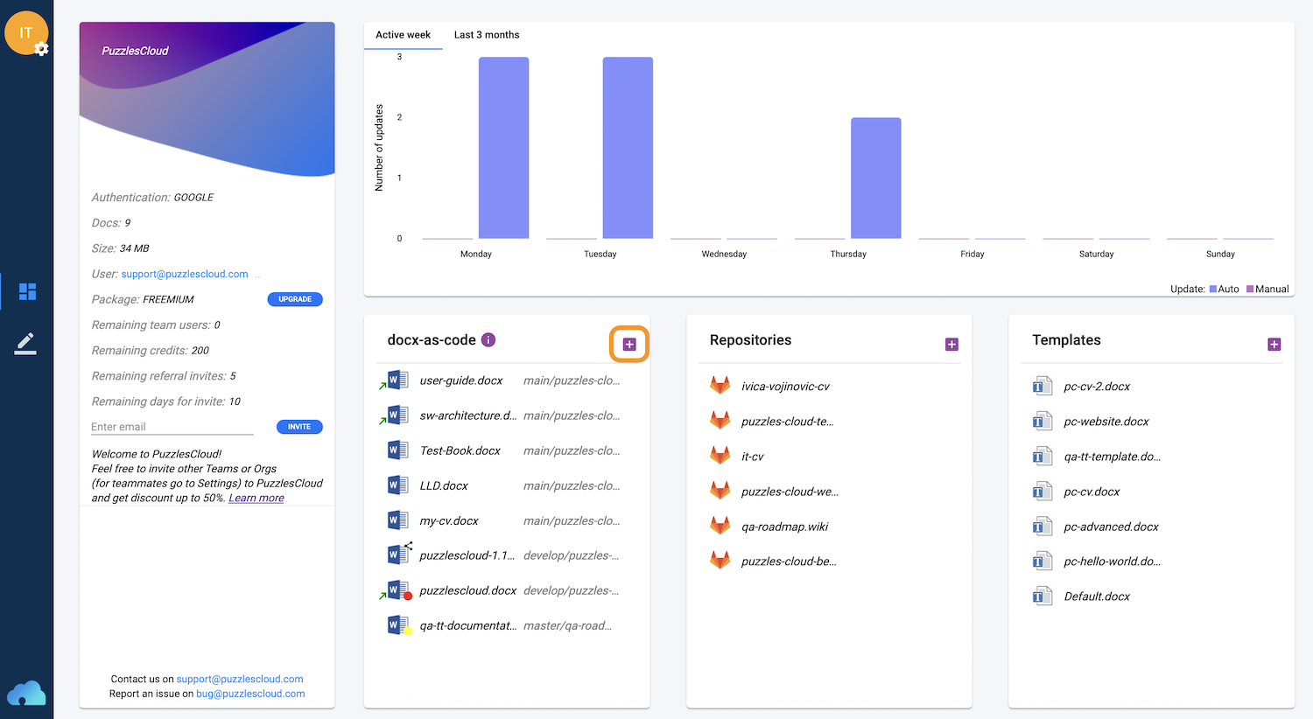

Figure 7 Add docx-as-code

The following window will appear:

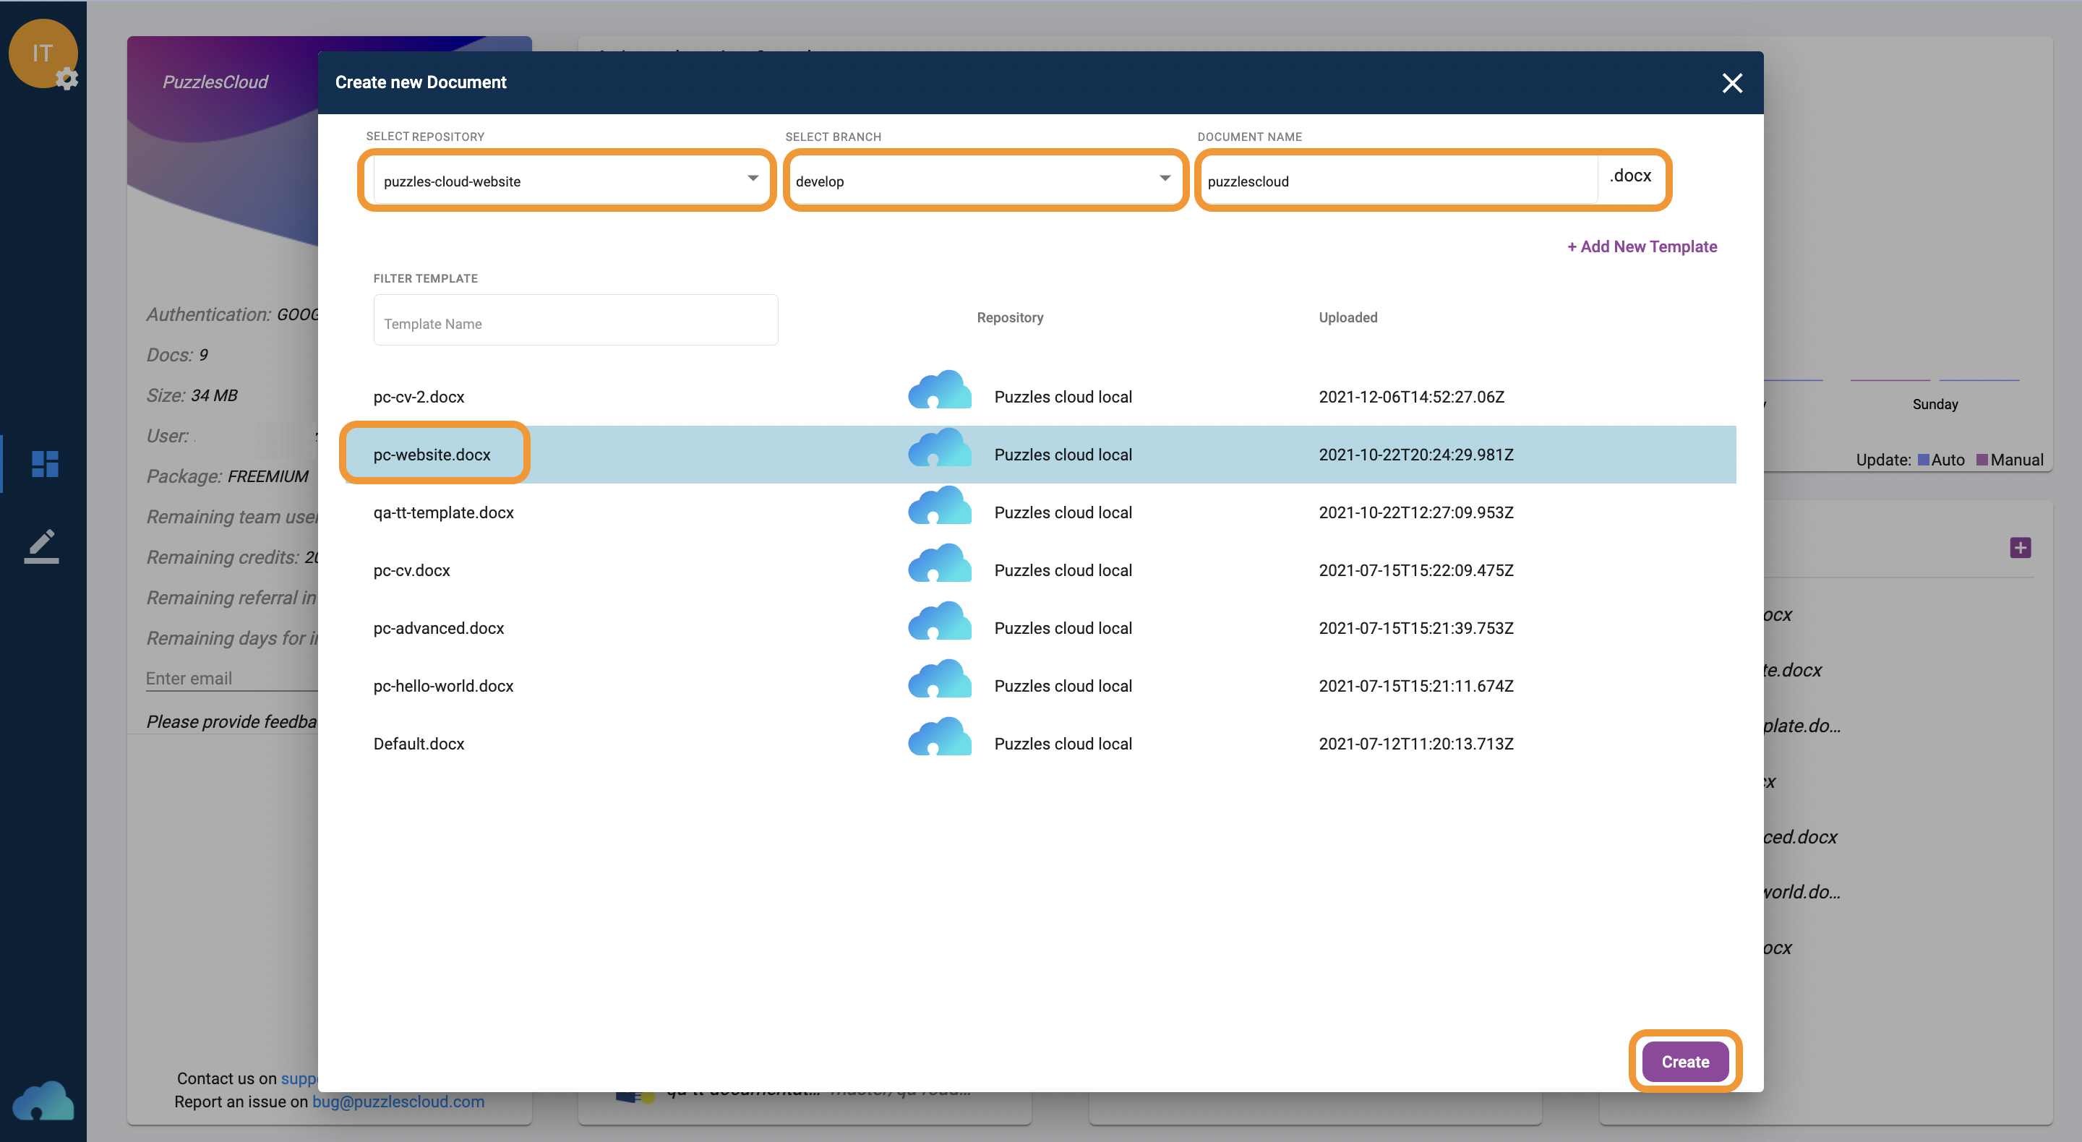

Figure 8 New docx-as-code

These are the mandatory fields:

* Select Repository (this is the Git repository to which new Doc will be pushed if opted),
* Select Branch (this is the Git branch to which new Doc will be pushed),
* Document Name (this is the name of the new doc),
* Template (this is the template to which you wish to put your content to).

After completing those you can click on the "Create" button.

The following window will appear:

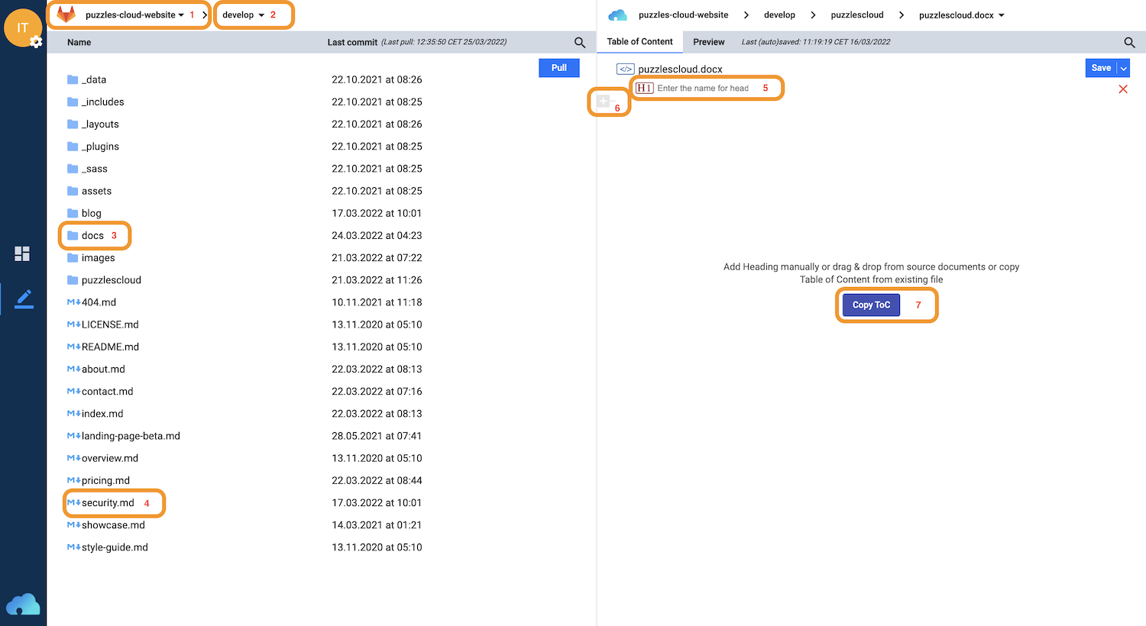

Figure 9 Create docx-as-code

You can select on the left hand side:

* Source Docs Git Repository (You can create a single Doc of multiple Git Repos) (1)
* Source Docs branch (2)

In order to pupulate Table of Content (ToC) part the following options are available:

* Drag&Drop Folder from source section (3)
* Drag&Drop a single file from source section (4)
* Enter manually Heading name (5)
* Add manually additinal Heading (6)
* "Copy Toc" by which ToC can be copied over from an existing docx-as-code (7)

The created document is shown below.

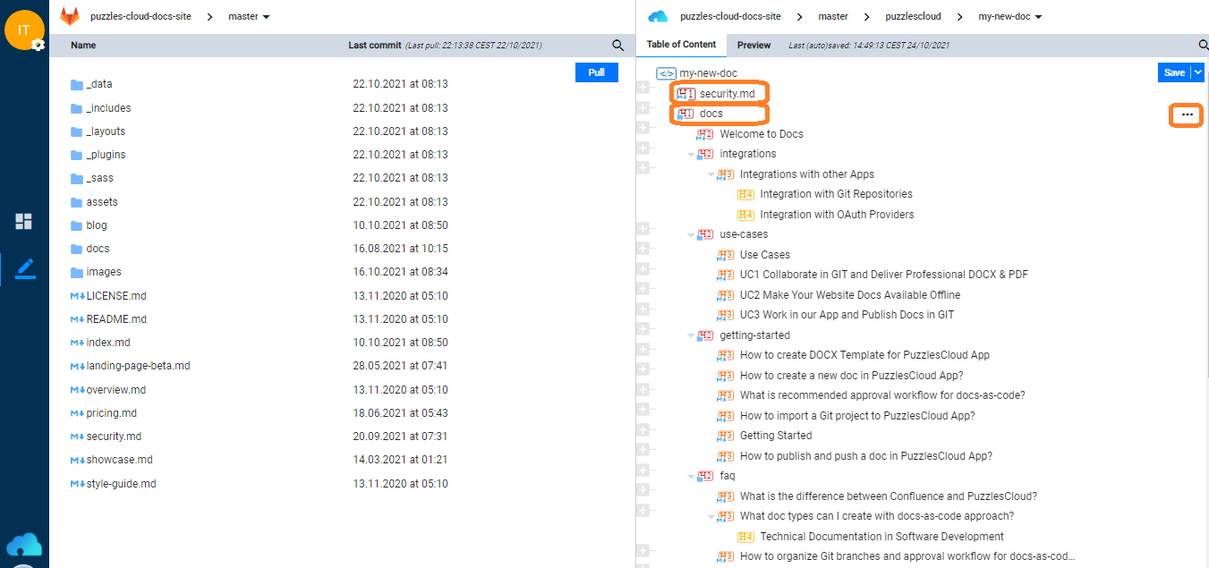

Figure 10 Created docx-as-code

Table of Content section can be re-ordered by Drag&Drop functionality.

Clicking on "..." for a given element in the ToC section shows additional options such as:

* View
* Edit
* Delete

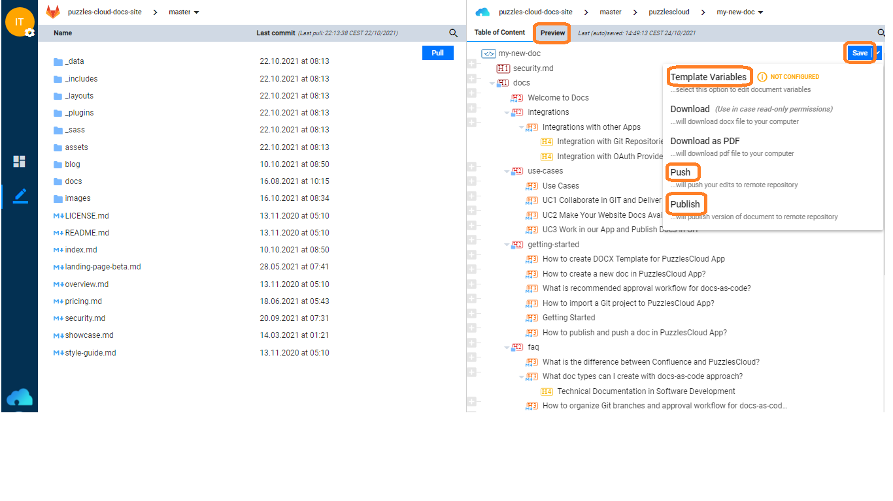

Figure 11 docx-as-code options

The following options are available for the created docx-as-code:

* Preview (it will show how DOCX/PDF will actually look like)
* Save (you can explicitely save the content altough autosave option is turned on by default)
* Template Variables (you can fill out Vars defined in the used DOCX Template)
* Download (DOCX)
* Download as PDF (PDF)
* Push (will push latest Doc edits to remote Git repository)
* Publish (will Publish versioned and released DOCX/PDF Doc on our Website and/or Google Drive)

### Publish Created Doc

In this section we will explain the workflow on how to publish created docx-as-code doc.



Figure 12 docx-as-code options

By clicking on the "Publish" option the following window will appear:

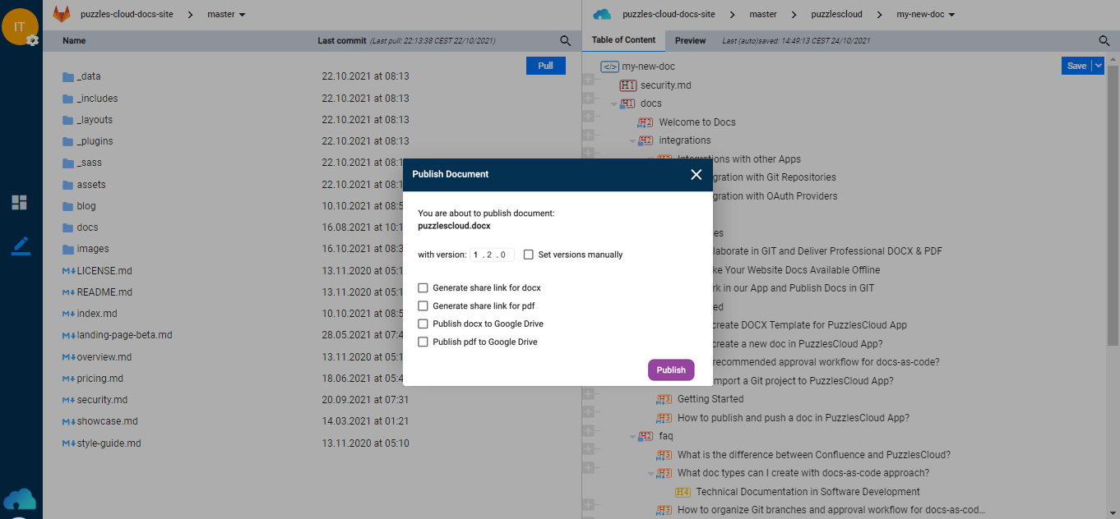

Figure 13 Publish docx-as-code

The doc will be versioned with the auto-versioning feature:

* Major (can be manually changed)
* Minor (will be automatically incremented on every publishing)
* Patch/bug fix (will be always 0)

If selected "Set Versions Manually" then auto versioning will be overrided and any non existing versions could be set.

By clicking on "Publish" button, read only versioned copy of the document will be created (e.g. puzzlescloud-1.0.0.docx). Main document will continue to live independently.

There are the following options with the published document:

* Generate share link for docx (will create link of the docx to be downloaded from PuzzlesCloud website)
* Generate share link for pdf (will create link of the pdf to be downloaded from PuzzlesCloud website)
* Publish docx to Google Drive (for Google authenticated users who allowed interaction between PuzzlesCloud and own Google Drive)
* Publish pdf to Google Drive (for Google authenticated users who allowed interaction between PuzzlesCloud and own Google Drive)

### Configure Webhook

In this section we will explain the workflow on how to configure our Webhook service for full document automation CI cycle.

On the Dashboard, next to the desired document, by clicking on "..." the following window will appear:

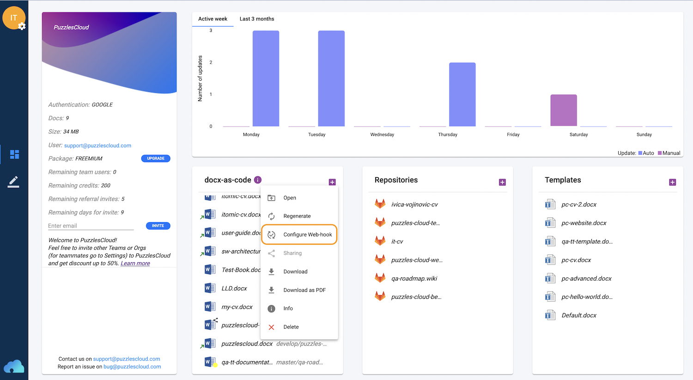

Figure 14 docx-as-code dashboard options

By clicking on the "Configure Web-hook" option the following window will appear:

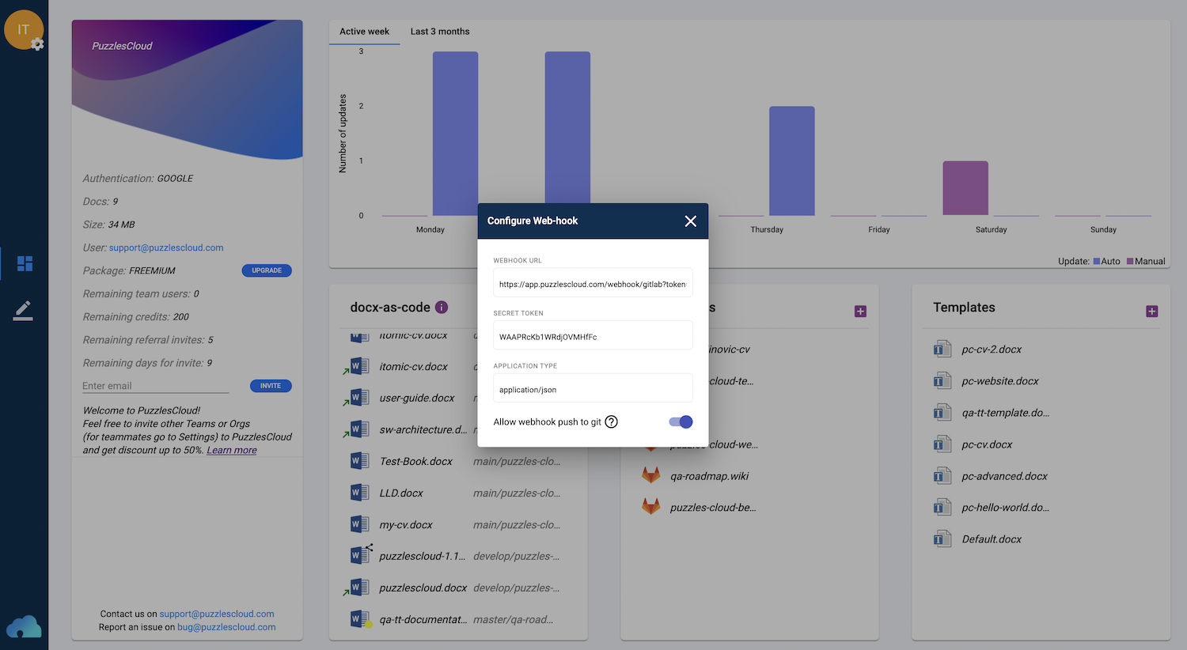

Figure 15 Configure Webhook

The dialog will show the following parameters and options:

* Webhook URL (required for Webhook configuration on Git provider side)
* Secret Token (required for Webhook configuration on Git provider side)
* Application Type (required for Webhook configuration on Git provider side)
* Allow webhook push to git (will allow built document to be pushed automatically to the Git repository)

The parameters provided above should be set in Git provider application under your Docs or Website Repository:

* GitLab - Settings > Webhooks
* GitHub - Settings > Webhooks > Add webhook

Make sure that Enable SSL verification option is enabled.

More details on configuring Webhooks for Git providers could be found bellow:

* [on GitLab](https://docs.gitlab.com/ee/user/project/integrations/webhooks.html)
* [on GitHub](https://docs.github.com/en/developers/webhooks-and-events/webhooks/about-webhooks)

### Add PDF/DOCX Download to your Jekyll Website

In this section we will explain how you could easily add a "Download" button to your Jekyll based Static Website.

To _includes folder add puzzlescloud.html file with the following content (feel free to adjust it).

<link rel="stylesheet" href="https://cdnjs.cloudflare.com/ajax/libs/font-awesome/4.7.0/css/font-awesome.min.css">  
 <style>  
 .pc-btn {  
 background-color: DodgerBlue;  
 border: 2px solid DodgerBlue;  
 border-radius: 1.75em;  
 box-sizing: border-box;  
 color: #fff;  
 display: inline-block;  
 font-size: 14px;  
 font-weight: bold;  
 letter-spacing: 0.035em;  
 line-height: 1.2;  
 padding: 0.5em 1.5em;  
 text-align: center;  
 text-decoration: none;  
 -webkit-transition: .3s ease;  
 transition: .3s ease;  
 vertical-align: middle;  
   
 &:hover,  
 &:focus,  
 &:active {  
 background-color: transparent;  
 color: DodgerBlue;  
 outline: 0;  
 }  
 }  
 .pc-btn-div {  
 padding-top: 1.5em;  
 }  
 </style>  
 <div class="pc-btn-div">  
 <a class="pc-btn" href="/puzzlescloud/puzzlescloud.pdf" download><i class="fa fa-download"></i> .pdf </a>  
 <a class="pc-btn" href="/puzzlescloud/puzzlescloud.docx" download><i class="fa fa-download"></i> .docx </a>  
 </div>

Files puzzlescloud.pdf and puzzlescloud.docx need to be pushed by our Webapp to /puzzlescloud folder

In _layouts folder to your <file name>.html file place to appropriate place the following line:

{ % include puzzlescloud.html % }

It will produce the buttons like below

{% include puzzlescloud.html %}

## use-cases

### Use Cases

In this section we cover our Application Use Cases, for Developers, DevOps/Agile/Product Teams, Tech Writers and Marketers.

Here are the articles in this section:

### Enable docx-as-code for your DevOps/Agile Team

Typical content writer spends 22h monthly for writing new content, and 44h for updates. Minimize time required for updates by automating docs, build and save 1.5 month per year.

* Follow [CI/CD DevOps infinite cycle](../../about/) for code and docs
* Leverage the best document version control system - Git (Merge Request and approval)
* Keep Docs close to code (in MarkDown) and decouple content writing from building the Doc
* Automate Document build (Styles, Doc captions, Table of Content/Tables/Figures, Page brakes)
* Easily split complex docs to modules and distribute writing to different teams
* Release your document in seconds
* Publish your doc in a single click

High level steps are:

1. Perform Initial Workflow to release your doc ([Create DOCX template](../../docs/getting-started/edit-docx-template/), Create Doc Project Repository and [Import it](../../docs/getting-started/import-git-docs-repo/), [Create a new doc](../../docs/getting-started/create-new-doc/), Configure Webhook Service and Release the Doc)
2. Publish your doc (Download Doc, push it to Repo, Share link for it or Publish to G Drive)
3. Update your doc (Using Git client only or our Webapp)

Does it sound interesting to you?

Check out detailed workflow in the following PlantUML diagram:

If interested to try it out, just start the journey (no credit card needed), or request a demo [Register for Freemium](https://app.puzzlescloud.com/account/register)[Request Demo](../../contact" \l "demo-request)

### Convert your Static Website to PDF

Enable a PDF download option for your Static Website and avoid paper prints. **Think GREEN!**

* Convert your Static Website (Jekyll, Hugo, Next.js, Gatsby) content, from Markdown to PDF - (e.g Jekyll is Static Site Generator used by GitHub Pages service)
* Avoid using HTML to PDF conversion and forget about CSS customization, use DOCX template and make your docs looking professional
* Automate the build process by using our Webhook service

High level steps are:

1. [Create professional corporate DOCX template](../../docs/getting-started/edit-docx-template/) for your Website PDF docs
2. [Import your Static Website Git project Repository](../../docs/getting-started/import-git-docs-repo/) to our Webapp
3. [Create a new doc](../../docs/getting-started/create-new-doc/) and Table of Content (ToC) of your PDF - drag&drop folders or MarkDown files
4. Preview your doc and, if happy, push to your Git project Repository
5. Do not forget document automation and [Configure Webhook service](../../docs/getting-started/webhook/) for automated document build cycle

You could also check [how to add PDF/DOCX download button to your Jekyll Website](../../docs/getting-started/add-download-jekyll/).

Does it sound interesting to you?

Check out detailed workflow in the following PlantUML diagram:

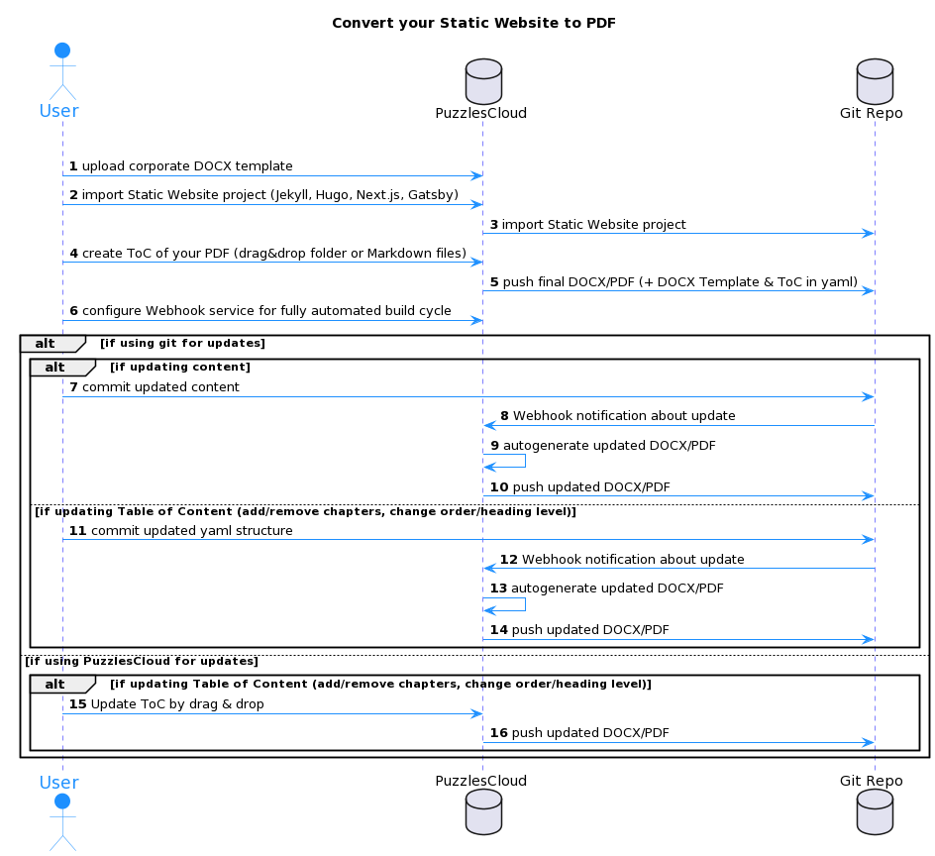

Figure 16 Convert your Static Website to PDF

If interested to try it out, just start the journey (no credit card needed), or request a demo [Register for Freemium](https://app.puzzlescloud.com/account/register)[Request Demo](../../contact" \l "demo-request)

### Publish Docs Without Pain

In this section we will explain the workflow on how you can work in our Webapp and publish docs in Git. The workflow is outlined in the following UML diagram:

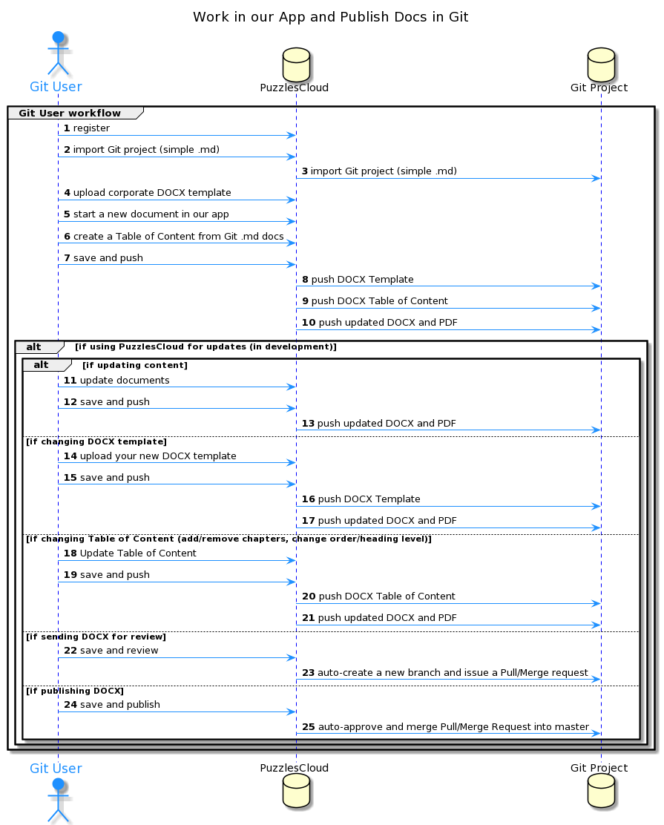

Figure 17 Work in our Webapp and Publish Docs in Git

If interested to try it out, just start the journey (no credit card needed), or request a demo [Register for Freemium](https://app.puzzlescloud.com/account/register)[Request Demo](../../contact" \l "demo-request)

## faq

### How to migrate Confluence data to Git based Wiki?

There are a couple of tools that could be used for this purpose. Some of them require HTML and some XML [Confluence space export](https://confluence.atlassian.com/doc/export-content-to-word-pdf-html-and-xml-139475.html" \l "ExportContenttoWord,PDF,HTMLandXML-ExportmultiplepagestoHTML,XML,orPDF).

[This tool](https://github.com/sjones4/confluence-to-github) is interesting, since it does not have any dependency, you can simply run the script.

The other option is [Metamug](https://metamug.com/util/confluence-to-markdown/).

It is convenient since it will remove any unnecessary HTML content (styles and other).

### What's the difference between Confluence & PuzzlesCloud?

Confluence is a HTML based Wiki documentation service for enterprises. As such, it does not practice docs-as-code principle and has very limited version control capabilities, as well as docs export capabilities. On the other hand, Git is the heart of the PuzzlesCloud solution and as such provides very powerful versioning capabilities and workflows. Both have options to leverage document templates, while PuzzlesCloud bases its templating concept on docx corporate templates, providing a highly professional look of the published documents.

The PuzzlesCloud Team is working on enriching the available document templates for many different purposes and use cases. Please stay tuned.

### What are docs-as-code typical doc types?

Variety of documentation that is convenient for docs-as-code approach is very high. Practically, all documentation that requires continuous delivery, or requires many releases before final one, is perfect fit. Main major categories can be divided the following way:

* Technical Documentation in Software Development
* Technical Documentation for DevOps
* Technical Documentation for Professional Services, etc.

#### Technical Documentation in Software Development

Software Project Documentation:

* Product Documentation
  1. System documentation
     + Software requirements documentation
     + User Experience documentation
     + Software Architecture documentation
     + Quality Assurance documentation
     + Maintenance and Help guides
     + Knowledge Bases
     + API documentation
  2. User documentation
     + End-users documentation
     + System admin documentation
     + Release Notes
* Process Documentation

We would recommend futher reading of this topic on the following [link](https://www.altexsoft.com/blog/business/technical-documentation-in-software-development-types-best-practices-and-tools/" \l "types-of-documentation).

### How to setup Git branches and approval workflow?

In this section we will explain how to organize Git branches and approval workflow for docs-as-code. The workflow is outlined in the following PlantUML diagram:

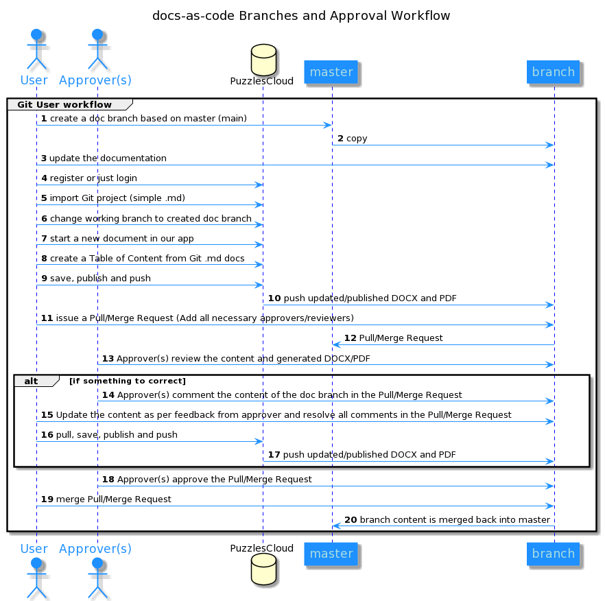

Figure 18 Git branches and approval workflow for docs-as-code

1. Create a doc branch based on master(main) branch
2. The branch with the same content like master(main) will be created
3. User(s) can update the documentation (.md files)
4. Register (if not already done) and login to our application
5. Import the Git project with docs
6. Change the working branch to the created doc branch
7. Start a new doc in our app
8. Create manually the structure (ToC) of the new document
9. Save your new doc in our application, publish to create a versioned copy and push to Git repo
10. Our application will push to your Git project new updated DOCX and PDF documents
11. Issue a Pull/Merge request to start approval/review process and add all optional/required approvers
12. Pull/Merge request will be issued for merging doc branch into master(main)
13. Approvers (optional and required) will review the content
14. (Optional) Approvers comment the content if something to correct in the Pull/Merge request
15. Users update the content as per feedback from approvers and resolve all comments (sometimes conducting the discussion) in the Pull/Merge request
16. Pull the new content, save your new doc in our application, publish to create a versioned copy and push to Git repo
17. Our application will push to your Git project new updated DOCX and PDF documents
18. Approvers confirm they are happy with the content by approving Pull/Merge request
19. User will merge Pull/Merge request (if not set to auto-complete)
20. The doc branch is merged into master(main) and your new content is now official

NOTE: Keep in your master(main) only approved content

### How to convert existing docx files into MarkDown?

The most convenient and reliable tool for this purpose is [Pandoc](https://pandoc.org/).

This article explains how to install Pandoc on different Operating Systems: <https://pandoc.org/installing.html>

Lackily enough, after installation you need a single command:

pandoc -f docx -t gfm input.docx -o output.md --extract-media=./

This command will convert input.docx file into output.md file with all input.docx figures (images) placed in --extract-media=./ folder. Cool, isn't it?

Oh yeah, output is gfm (GitHub-Flavored Markdown). All needed now is to commit your new output.md into Git Repo to be able to use it in our app.

### How to setup Git repo to prevent undesired pushes?

There are two main approaches you can take to prevent undesired pushes:

* protected branches
* push rules

#### Protected Branches

In order to setup a protected branch please check these docs out:

* [GitHub Protected Branches](https://docs.github.com/en/github/administering-a-repository/defining-the-mergeability-of-pull-requests/about-protected-branches)
* [GitLab Protected Branches](https://docs.gitlab.com/ee/user/project/protected_branches.html)

#### Push Rules

In order to setup a Push Rule please check this doc out:

* [GitLab Push Rules](https://docs.gitlab.com/ee/push_rules/push_rules.html)

### FAQ

In this section you'll find commonly asked questions regarding our application. It is work in progress, stay tuned.

### Where is your SaaS hosted?

We are hosting our SaaS solution at [Hetzner Dedicated](https://www.hetzner.com/), location Falkenstein, Germany.

This hosting provider has got the highest security, internationally recognized, standards and certifications DIN ISO/IEC 27001. [Read more](https://www.hetzner.com/unternehmen/zertifizierung/)

### How to leverage Wiki pages for docx-as-code?

You can transform your Wiki pages into professional looking documentation ready for customer delivery, in only a couple of clicks.

NOTE: Your Wiki needs to be Git based and written in MarkDown format.

The steps are:

1. Find Wiki clone link

* for [GitHub](https://gist.github.com/subfuzion/0d3f19c4f780a7d75ba2)
* for [GitLab](https://docs.gitlab.com/ee/user/project/wiki/" \l "create-or-edit-wiki-pages-locally)
* for [Azure DevOps](https://docs.microsoft.com/en-us/azure/devops/project/wiki/wiki-update-offline?view=azure-devops" \l "clone-your-wiki)

1. [Import Git Wiki repo](../../docs/getting-started/import-git-docs-repo/)
2. [Edit DOCX Template (Optional)](../../docs/getting-started/edit-docx-template/)
3. [Create a New docx-as-code](../../docs/getting-started/create-new-doc/)
4. [Publish the Doc](../../docs/getting-started/publish-doc/)

## policies

### Policies

In this section we cover our Policies, what are the terms under which you can use the App, how we handle your data and many more.

Here are the articles in this section:

### Privacy Policy

**Effective:** 24.11.2020

PuzzlesCloud takes your privacy seriously. With this document we want to disclose how information about you is used and shared, and we appreciate the trust that you place in us. Moreover, our Privacy Policy explains what information we collect from you, also how we use that information, and what choices you have with respect to that personal information. Throughout this Privacy Policy, we use the term "Personal Data" to describe information that can be associated with a specific person and could be used to identify that person or a company. References in this Statement to "we," "us" or "our" are references to the PuzzlesCloud entity that is operating the relevant Website, or providing the applicable Services. Statements referring to "you" or "your" are references to the company or individual we are collecting Personal Data about. We do not consider Personal Data to include information that has been made anonymously or aggregated so that it can no longer be used, whether in combination with other information or otherwise, to identify a specific person. By registering you consent to the collection, use and transfer of your information under the terms of this Policy. PuzzlesCloud respects individual privacy. PuzzlesCloud strives to collect and use Personal Data in a manner consistent with the laws of the countries in which it does business.

#### Data Types and Collection Methods

1. Personal Data - Information we request from you
2. Statistical & Activity Data - Information we collect from you
3. Customer Business Data (The Content) - Information you share with us

#### Data Collection Purpose and Data Usage

We will use your **Personal and Statistical & Activity Data** for a range of different purposes including:

1. To respond to your specific inquiry or request and to provide you with information and access to resources that you have requested from us;
2. To administer, protect, operate and maintain the Website and our systems;
3. To improve the navigation and content of our Website, system administration and security;
4. To compile aggregated statistics about the site usage and to better understand the preferences of our site visitors;
5. To help deliver our Services to our customers and to provide customer service and support;
6. To process and complete business transactions and send related information, including transaction confirmations and invoices;
7. To send information to our customers about their account, technical alerts or updates, and other administrative or service-related communications;
8. To carry out research and development to improve our Services;
9. To carry out other legitimate business purposes, as well as other lawful purposes about which we will notify our users and customers.

We will use your **Customer Business Data** exclusively to provide the Service you have requested.

#### Data Transfer and Links to Third Parties

We do not sell or disclose any of your data to companies, organizations or individuals outside of PuzzlesCloud. We may share only your Personal Data with trusted agents or consultants in order to improve the quality of PuzzlesCloud support service. Customer Business Data will not be exposed to any third parties by any means. PuzzlesCloud website may contain links to other sites that are not owned or controlled by PuzzlesCloud. Please be aware that we, PuzzlesCloud, are not responsible for the privacy practices of such other sites. We encourage you to be aware when you leave our site and to read the privacy statements of each and every website that collects personally identifiable information. This Privacy Policy applies only to the information collected by our website.

#### Legal and Other Disclosures

Under certain circumstances, we may be required to disclose your personal information in response to valid requests by public authorities, including to meet national security or law enforcement requirements.

We may disclose your personal information if required to do so by law in order to (for example) respond to a subpoena or request from law enforcement, a court or a government agency, or in the good faith belief that such action is necessary (a) to comply with a legal obligation, (b) to protect or defend our rights, interests or property or that of third parties, (c) to prevent or investigate possible wrongdoing in connection with the Site or our Services, (d) to act in urgent circumstances to protect the personal safety of users of the site, our Services or the public; or (e) to protect against legal liability.

We may share or transfer your information in connection with a prospective or actual sale, merger, transfer or other reorganization of all or parts of our business. Also, we reserve the right to fully use and share any information that is not in personally identifiable form (such as statistics and survey results that do not identify you individually by name).

#### Security

We continuously invest our efforts and resources to improve security of PuzzlesCloud and all user data. We follow generally accepted best practice industry standards to protect the Personal Data and Customer Business Data submitted to us, in particular:

1. We encrypt the transmission of that information using secure socket layer technology (SSL);
2. We keep all Customer Business Data encrypted in the database;
3. We keep access to the database to restricted PuzzlesCloud employees;
4. We keep clear separation between frontend and backend services where backend services are fully protected;

For our web systems on which you have a user account, you have access to your information to update and maintain your profile. It is solely your responsibility to maintain the confidentiality of your password. If you believe your password has been compromised, please contact [support@puzzlescloud.com](mailto:support@puzzlescloud.com) . If your personally identifiable information changes, or if you no longer desire to receive marketing materials, you may correct, update, delete or deactivate it by emailing . PuzzlesCloud will respond to your request within 24 hours of receiving the request. Your account is active for as long as needed to provide you services and comply with our legal obligations, resolve disputes, and enforce our agreements. Your password is the key to your account. Use unique numbers, letters and special characters, and do not disclose your PuzzlesCloud password to anyone. If you do share your password or your personal information with others, remember that you are responsible for all actions taken in the name of your account. If you lose control of your password, you may lose substantial control over your personal information. It is important for you to protect against unauthorized access to your password and to your computer, so be sure to sign off when finished using a shared computer.

PuzzlesCloud serves as a Data Processor for the clients who use these applications. More specifically, PuzzlesCloud does not own the Customer Business Data that is submitted to our applications. The information that is submitted to our applications will be subject to our clients' privacy policies.

No method of transmission over the Internet, or method of electronic storage, is 100% secure, however. PuzzlesCloud is not responsible for any interception or interruption of any communications through the Internet or for changes to or losses of information. Therefore, while we strive to use commercially acceptable means to protect your personal information, we cannot guarantee its absolute security.

If you have any questions about security on our Website, you can send email us at [support@puzzlescloud.com](mailto:support@puzzlescloud.com).

#### Changes to Our Privacy Policy

We reserve the right to modify this Privacy Policy at any time, so please review it frequently. If we make material changes to this Policy, we will notify you here, or by email, or by means of a notice on our home page so that you are aware of what information we collect, how we use it, and under what circumstances, if any, we disclose it.

#### Contact

All comments, queries and requests relating to our use of your information are welcomed and should be addressed to [support@puzzlescloud.com](mailto:support@puzzlescloud.com).

**Sincerely yours, The PuzzlesCloud Team**

### Terms and Conditions

**Effective:** 12.12.2021

Welcome to the PuzzlesCloud website ("the Site", "the Website"). Through the Site, you have access to the Software as a Service ("the Service") offering. Please read these Terms of Service carefully before accessing or using our website. By accessing or using any part of the site, you agree to be bound by these Terms of Service. If you do not agree to all the terms and conditions of this agreement, then you may not access the website or use any services. If these Terms of Service are considered an offer, acceptance is expressly limited to these Terms of Service. Please note that you retain all rights and ownership you have in your content that you make available through the Services. If you do not wish to be bound by these Terms and Conditions then you may not use our Website, however you can contact us to discuss your constraints.

1. Reservation of Rights

The Site and Content provided on or through the Site are the intellectual property and copyrighted works of PuzzlesCloud or a third party provider. All rights, title and interest not expressly granted with respect to the Site and Content provided on or through the Site are reserved.

1. About PuzzlesCloud

PuzzlesCloud is a trading name of PuzzlesCloud d.o.o an incorporated company under the laws of Serbia with registration number 21727016 and tax number 112725058.

1. Registration for the Service

Our Services requires you to open an account. You must complete the registration process by providing us with current, complete and accurate information as required by the applicable registration form. User who is opening an Account on behalf of some company, must be entitled to represent that company. By opening an PuzzlesCloud Account User commits to us that action does not violate any laws or regulations applicable to him. You will be required to choose a password or 3rd party authentication provider. Access to and use of password protected or secured areas of the Site are restricted to authorized users only. You agree not to share your password(s), account information, or access to the Site with any other person. You are responsible for maintaining the confidentiality of password(s) and account information, and all activities that occur through the use of your password(s) or account(s) or as a result of your access to the Site. You agree to notify PuzzlesCloud immediately of any use of your password(s) or account(s) that you did not authorize or that is not authorized by these Terms and Conditions.

1. Use of the Service

Subject to your compliance with these terms and the law, you may access and use the Services. PuzzlesCloud remains the sole owner of all right, title, and interest in the Services and Software. We reserve all rights not granted under these terms. Our Service provides storage, we recommend that you backup your generated documents regularly. We may create reasonable technical limits on your content, such as limits on file size, storage space, processing capacity, and other technical limits. Users can communicate with us and submit suggestions, ideas, comments, feedbacks, questions or any other information as long as the content is not illegal, obscene, threatening, invasive of privacy, infringing of intellectual property rights, or otherwise injurious to third parties or objectionable and does not consist of or contain software viruses, political campaigning, commercial solicitation, chain letters, mass mailings, or any other form of "spam".

1. Our Packages

We are offering the packages described under the following link: <https://puzzlescloud.com/pricing/>

1. Customer Support Service

We strive to provide excellence in our services, however customers will be served without any service level guarantees, unless otherwise is specified in the corresponding service Package.

The best and the fastest way to open a customer service or technical support ticket through the Application Dashboard page or drop us an email: [support@puzzlescloud.com](mailto:support@puzzlescloud.com).

1. Invoicing and Service Payment

Invoices will be sent out once a month or year depending on plan type. Payment deadline is 10 days after customer has been invoiced.

1. Your Content

Our Service allows you to upload, store and generate content. You retain ownership of any intellectual property rights that you hold in that content. In short, what belongs to you stays yours. Our systems may analyze your content in course of providing you relevant application features (such as content search results). We don't use analysis outcome of your content for any other purposes except providing application functionalities. We do not monitor or control what your account users do with your content. You are responsible for determining the limitations that are placed on your content and for applying the appropriate level of access to your content. If you do not choose the access level to apply to your content, the system may default to its most permissive setting. It's your responsibility to let other users know how your content may be shared and adjust the setting related to accessing or sharing of your content. You can find more information about how PuzzlesCloud uses, stores and secures the Content in the privacy policy.

1. Prohibited Actions

The PuzzlesCloud community often consists of users who expect a certain degree of courtesy and professionalism. You must use the Services responsibly. You agree not to access or use the Site in any manner that could damage, disable, overburden, or impair any PuzzlesCloud accounts, computer systems or networks. You agree not to attempt to gain unauthorized access to any parts of the Site or any PuzzlesCloud accounts, computer systems or networks. You agree not to interfere or attempt to interfere with the proper working of the Site or any PuzzlesCloud accounts, computer systems or networks. You agree not to use any robot, spider, scraper or other automated means to access the Site or any PuzzlesCloud accounts, computer systems or networks without PuzzlesCloud express written permission. You must not misuse the Services, Software, or content that we provide to you as part of the Services. For example, you must not:

1. Copy, modify, host, stream, sublicense, or resell the Services, or content;
2. Enable or allow others to use the Service, or content using your account information;
3. Use the content or Software included in the Services to construct any kind of database;
4. Access or attempt to access the Services by any means other than the interface we provided or authorized;
5. Circumvent any access or use restrictions put into place to prevent certain uses of the Services;
6. Share content or engage in behaviour that violates anyone's Intellectual Property Right ("Intellectual Property Rights" means copyright, moral rights, trademark, trade dress, patent, trade secret, unfair competition, right of privacy, right of publicity, and any other proprietary rights);
7. Upload or share any content that is unlawful, harmful, threatening, abusive, tortious, defamatory, libelous, vulgar, lewd, profane, invasive of another's privacy or hateful;
8. Impersonate any person or entity, or falsely state or otherwise misrepresent your affiliation with a person or entity;
9. Attempt to disable, interrupt, negatively impact, impair, or destroy the PuzzlesCloud Services, software, or hardware;
10. Disrupt, interfere with, or inhibit any other user from using the Services (such as stalking, intimidating, or harassing others, inciting others to commit violence, or harming minors in any way),
11. Engage in chain letters, junk mails, pyramid schemes, spamming, or other unsolicited mess;
12. Commercialize any information or software associated with PuzzlesCloud platform;
13. Use any data mining or similar data gathering and extraction methods in connection with the Services; or
14. Violate applicable law.
15. Copyright and Monitoring

The contents of the Site are protected by international copyright laws and other intellectual property rights. The owner of these rights is PuzzlesCloud or other third party licensors. All product and company names and logos mentioned in our Website are the trademarks, service marks or trading names of their respective owners, including us. Copyright© 2021, PuzzlesCloud and/or its subsidiaries/affiliates. All rights reserved.

1. Electronic Communications and Contract

When a User uses PuzzlesCloud Service, or send e-mails to us, he is communicating with us electronically. User consent to receive communications from us electronically. We will communicate with the User by e-mail or by posting notices on this site. User agrees that all agreements, notices, disclosures and other communications that we provide to user electronically satisfy any legal requirement by domestic or international law that such communications be in writing. By registering on the PuzzlesCloud Website, contract between User and PuzzlesCloud is considered concluded, in accordance with article 7, of Law on foreign exchange operations.

1. Privacy Policy

PuzzlesCloud is taking care about your privacy and has developed a policy to address privacy concerns. For more information, please see PuzzlesCloud's Privacy Policy that is integral part of the Terms and Conditions.

1. Termination of Use

You may stop using the Services at any time. Termination of your account does not relieve you of any obligation to pay any outstanding fees. Under specific circumstances, based on reasonable grounds PuzzlesCloud reserves right to refuse, temporarily suspend or otherwise restrict access to the website or it's functionalities to any user without any notice (if it is possible we will make reasonable effort to notify you in the timely manner prior to termination).

Potential reasons for termination or access limitation are:

1. You breach any provision of these terms (or act in a manner that clearly shows you do not intend to, or are unable to, comply with these terms);
2. You fail to make the timely payment of fees for the Services, if any;
3. We are required to do so by law (for example, where the provision of the Services to you is, or becomes, unlawful);
4. We elect to discontinue the Services, in whole or in part, (such as if it becomes impractical for us to continue offering Services in your region due to change of law);
5. Linked Sites

The Site provides links to Web sites and access to Content, products and services of third parties, including users, advertisers, affiliates and sponsors of the Site. PuzzlesCloud is not responsible for third party Content provided on or through the Site or for any changes or updates to such third party sites, and you bear all risks associated with the access to, and use of, such Web sites and third party Content, products and services.

1. Availability of the Website

We use all necessary measures to keep our Site highly available but cannot guarantee that our Website will operate continuously or without interruptions or be error free and can accept no liability for its unavailability or errors on or in it.

1. The Application Updates

PuzzlesCloud is constantly changing and improving our Services. We may add or remove functionalities or features, and we may suspend or stop a Service altogether.

1. Terms and Conditions Updates

We may assign, novate or subcontract any or all of our rights and obligations under these terms and conditions at any time. We may alter these terms and conditions from time to time and post the new version on our Website, following which all use of our Website will be governed by that version. We'll post notice of modifications to these terms on this page and in the applicable Service. Changes will not apply retroactively and will be effective starting from the date published on this page. We reserve the right to defer the date of delivery, amend the order or the Services (including without limitation, the amount ordered or their specification) if we are prevented from or delayed in carrying on our business due to circumstances beyond our reasonable control.

1. Disclaimer

EXCEPT WHERE EXPRESSLY PROVIDED OTHERWISE, THE SITE, AND ALL CONTENT PROVIDED ON OR THROUGH THE SITE, ARE PROVIDED ON AN "AS IS" AND "AS AVAILABLE" BASIS. PUZZLESCLOUD EXPRESSLY DISCLAIMS ALL WARRANTIES OF ANY KIND, WHETHER EXPRESS OR IMPLIED, INCLUDING, BUT NOT LIMITED TO, THE IMPLIED WARRANTIES OF MERCHANTABILITY, FITNESS FOR A PARTICULAR PURPOSE AND NON-INFRINGEMENT WITH RESPECT TO THE SITE AND ALL CONTENT PROVIDED ON OR THROUGH THE SITE. PUZZLESCLOUD MAKES NO WARRANTY THAT: (A) THE SITE OR CONTENT WILL MEET YOUR REQUIREMENTS; (B) THE SITE WILL BE AVAILABLE ON AN UNINTERRUPTED, TIMELY, SECURE, OR ERROR-FREE BASIS; (C) THE RESULTS THAT MAY BE OBTAINED FROM THE USE OF THE SITE OR ANY CONTENT PROVIDED ON OR THROUGH THE SITE WILL BE ACCURATE OR RELIABLE;

ANY CONTENT ACCESSED, DOWNLOADED OR OTHERWISE OBTAINED ON OR THROUGH THE USE OF THE SITE IS USED AT YOUR OWN DISCRETION AND RISK. PUZZLESCLOUD SHALL HAVE NO RESPONSIBILITY FOR ANY DAMAGE TO YOUR COMPUTER SYSTEM OR LOSS OF DATA THAT RESULTS FROM THE DOWNLOAD OR USE OF CONTENT. PUZZLESCLOUD RESERVES THE RIGHT TO MAKE CHANGES OR UPDATES TO, AND MONITOR THE USE OF, THE SITE AND CONTENT PROVIDED ON OR THROUGH THE SITE AT ANY TIME WITHOUT NOTICE.

1. Contact Information

If you have any questions regarding these Terms and Conditions, please contact PuzzlesCloud at [info@puzzlescloud.com](mailto:info@puzzlescloud.com)

1. Definitions

"We", "us", "our" stands for PuzzlesCloud team.

"PuzzlesCloud Website", "The Website" or "The Site" stands for the website available at [https://puzzlescloud.com](https://puzzlescloud.com/)

"The Account" is a company's account that can be opened and maintained through PuzzlesCloud Website.

"User" stands for the person that has rights to access the Account, and that uploads, shares, and generate content on our Website.

"The Content" stands for Business Information (Documents) that Users upload, share and generate on our Website.

"Package" is a service described under <https://puzzlescloud.com/pricing/>

"Privacy Policy" is the PuzzlesCloud's policy governing the processing of personal data that is available on our Website, as may be amended from time to time.

"Terms and Conditions", stands for these Terms and Conditions under which an Account can be opened and used, published on the Website and as may be amended from time.

**Sincerely yours, The PuzzlesCloud Team**

# blog

## How to Maximize Content Reuse of Tech Documentation?

Holy Grail question of Tech Documentation is the one from the title: **How to Maximize Content Reuse of Tech Documentation?** We offer very simple and affordable solution: **Use MarkDown and Git Repos**

Why those?

Well, with these tools you can achieve maximized results, all you need is to keep single source of truth in MarkDown, which is building block of many tools and approaches. The reasons which contribute to the statement:

1. UC1 - You can always write content direcly to MarkDown in your content repo - **random articles, design docs, or internal writeups reuse**
2. UC2 - There are widly spread tools which convert MarkDown into HTML, called Static Site Generators (SSGs) - **website content reuse**
3. UC3 - Most of the Wiki providers are Git based (all content is in the background kept as Git project written in MarkDown format) - examples are GitHub, GitLab and Azure DevOps wiki pages (the only exception is Atlassian Confluence) - **Wiki pages content reuse**

In the further lines we will elaborate those three aspects.

### Static Site Generators

[Static Site Generators](https://jamstack.org/generators/) (SSG) convert practicaly static MarkDown content into HTML websites. The most relevant are Jekyll, Next.js, Hugo, Gatsby and the others.

For instance, available Jekyll themes could be found on [Jekyll themes IO website](https://jekyllthemes.io/) or [Jekyll themes org website](http://jekyllthemes.org/)

[GitHub Pages](https://pages.github.com/) and [GitLab Pages](https://docs.gitlab.com/ee/user/project/pages/) services for static content are based on SSGs and both supporting Jekyll SSG.

These are the examples of the docs source content on: [GitHub](https://github.com/github/docs). [Microsoft](https://github.com/MicrosoftDocs/azure-docs)

Microsoft has introduced even a [docs feedback system](https://docs.microsoft.com/en-us/teamblog/a-new-feedback-system-is-coming-to-docs) based on GitHub functionalities and ticketing system

### Wiki Content

Major Git providers also provide Git based Wiki pages:

1. [GitHub](https://docs.github.com/en/communities/documenting-your-project-with-wikis)
2. [GitLab](https://docs.gitlab.com/ee/user/project/pages/)
3. [Azure DevOps](https://docs.microsoft.com/en-us/azure/devops/project/wiki/wiki-create-repo)

For all of them is common that HTML is frontend for creation, however all of them are kept in Git repos as MarkDown files. That helps a lot to our goal of unifying the way of storing the Tech Documentation content.

### Native MarkDown Content

There are many tools available for writing native MarkDown. Some examples are given on [Oberlo's blog post on markdown editors](https://www.oberlo.com/blog/markdown-editors)

### Our Recommended Approach

Essentially, all major players are converging to MarkDown and Git. This is completely aligned with our approach, since all of the created content can be easily reused with our recommended approach and custom fancy docs, in corporate templates, can be created in couple of seconds for internal or external publishing.

Recommended workflow is outlined on the PlantUML diagram below

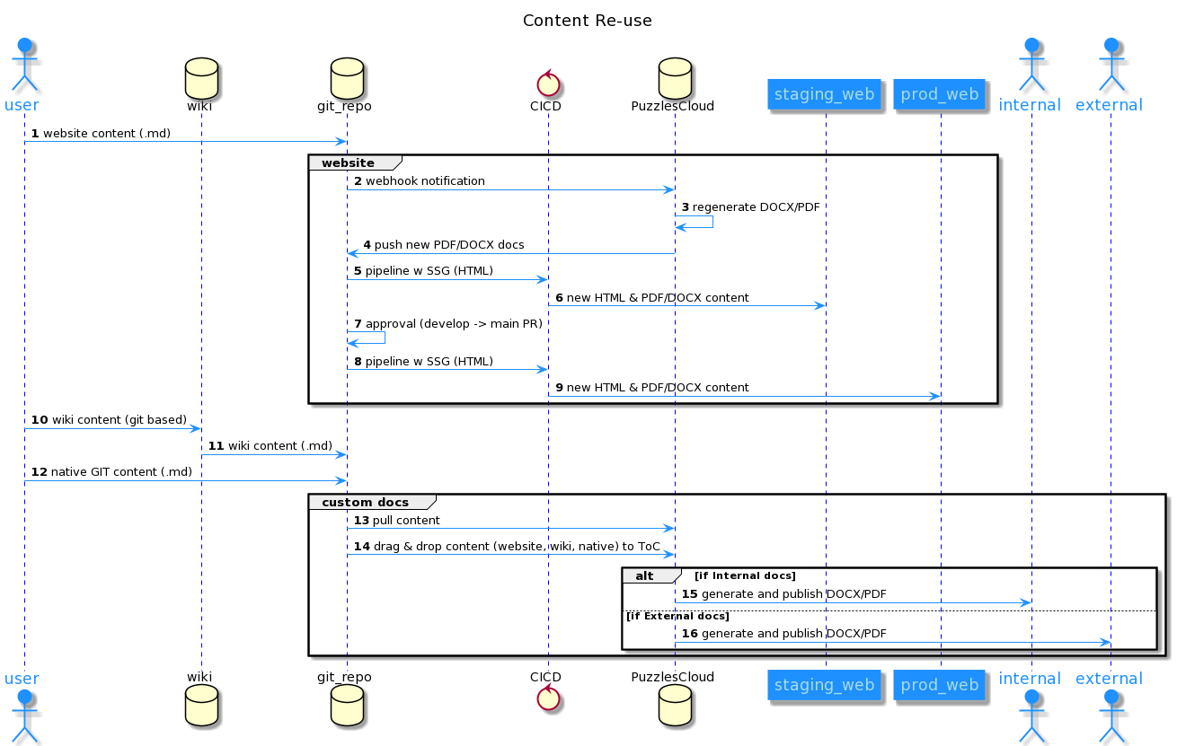

Figure 19 content-reuse

## How Customer Success Engineer can benefit from docx-as-code?

Customer Success Engineers are as its title says, customer focused. On the other hand our docx-as-code git based solution produces high quality customer docs. Find out how these two fit together.

### What is the role of Customer Success Engineer?

Today, together with the rise of digital transformation and the urgent needs of IT solutions in the competitive marketplace -- introducing a strong and competent success team has been one of the top priorities of the companies. Critical role in those departments is Customer Success Engineer (or sometimes called Solution Engineer, Application Engineer, Implementation Specialist etc.).

**Typical goal of Customer Success Engineer is to offer technical deployment or implementation of the products and services to the customers.**

Usual responsibilities are:

* Customer Facing:
  1. Onboarding of the customers to the applications
  2. Suggestions for the improvements and enhancements in customer implementation
  3. Deep understanding of customer processes and workflows
  4. Technical Support of the onboarded customer
  5. Deep troubleshooting and resolutions of customer issues ASAP
* Internally facing:
  1. Suggestions for application improvements
  2. Internal and external documentation enhancements
  3. collaboration with all internal teams for quick customer issues resolution
  4. application testing activities for the customer issues
  5. Internal projects as needed

### How can a Customer Success Engineer achieve more with less?

For Customer Success Engineers, customer is top priority. There is no time enough for secondary activities, such as documentation of the work done or planned.

Well, you don't need extra time. Make Pro customer deliverables in a couple of clicks with [PuzzlesCloud solution](https://puzzlescloud.com/pricing/). Save your time and make your company look more professional.

All you need is:

* to know Git (this should not be a problem for well skilled Customer Success Engineer)
* to have your source docs written in MarkDown format. It could be:
  1. Your public website documentation if source docs written in MarkDown (Website uses Static Site Generators for instance)
  2. Your internal Wiki Pages (git based)
  3. Your custom content for the customer

With this approach the only concern is to select existing content convenient for the customer, or build custom articles specific to the customer. Drag and Drop your content to the final doc and that is it.

All of the rest will be already in place.

* Table of content,
* Table of Tables,
* Table of Figures,
* Corporate docx Template (created by marketing department),
* Automated formating,
* High professional look.
* And many more.

Documentation that Customer Success Engineer could deliver to the customer is:

* Customer Onboarding Guides
* Customer Implementation Docs
* Implementation Improvement Docs
* Root Cause Analysis docs (for the issues faced)
* Custom User Guides (only for features implemented and used by the customer)
* Custom Release Notes (only tracking issues th customer is facing or features interested in).

Get to the next level of customer focus and success!

## Raising Starts Program Finalists

### Partnership with Raising Starts Program

The PuzzlesCloud Team has been selected to participate in the Raising Starts program designed to support startups in the earliest development stages, which with the support of the Government of Switzerland implements the Science Technology Park Belgrade. Through work with mentors, training and comprehensive professional support, the Program will enable us to acquire knowledge and skills to accelerate the development of our innovation, open the doors of the global market and reach new potential investors.

The program is implemented within the project "Technopark-Serbia 2 - Encouraging exports through the development of technological parks", by which the Government of Switzerland supports the further development of innovations and expansion of the network of technology parks, conducted by the Science and Technology Park Belgrade.

More information about the program is available at [NTPark's website](https://ntpark.rs/raising-starts/)

## StarTech Program Winners

**The PuzzlesCloud Team is proud to announce that has been selected as one of the winners of the StarTech Program in competition of 229 applicants and received a grant for further business and product development, which will strengthen our position on the market.**

### About StarTech Program

The StarTech program is founded to support the digital transformation of small and medium enterprises and is part of a three-year project for the promotion of innovation and technological development in Serbia, implemented by NALED and funded by Philip Morris. The goal of the project is to accelerate the growth of Serbian companies and the transformation of the traditional economy into digital, and to provide support in the form of funds and expertise, work on improving the conditions for encouraging innovation and promoting domestic innovative businesses.

More information about the program is available at (only in Serbian) [Startech's website](https://startech.org.rs/o-projektu)

## Why docs-as-code?

### Introduction

Documentation as Code Concept (docs-as-code) is getting more into the focus. Considering that many organizations, even outside of IT, are moving to Agile and DevOps ways of operation and docs-as-code concept natively supports it, it is completely natural that is getting so much attention.

Documentation as Code (docs-as-code) refers to a philosophy of writing documentation with the same tools as code. The most popular tool nowadays for writing, developing and maintaining code is Git version control system. Git in combination with MarkDown (you probably wrote a lot README.md files) is most convenient for docs-as-code as well. Documentation written this way is called source and represents single source of truth. In other words, can be converted to any other form, namely HTML, PDF, DOCX, or any other needed. This conversion is usually happening with CI/CD pipelines, therefore automatically. Considering previous conversion use cases, we could divide the concept into two areas:

* Docs-as-code for online documentation (generated static HTML pages out of the source files)
* Docs-as-code for offline docs delivery(generated PDF, DOCX or any other documents)

### Docs-as-code for Online Docs and Blogs

The technical concept of having static content in Git and out of it create static websites (docs, blogs) is supported by Static Site Generators and is called Jamstack. With this concept all documentation is kept as the source files, in one of the lightweight markup languages, such as MarkDown, asciidoc or similar formats. Those files are converted by some of the Static Site Generators to HTML pages, or other formats (e.g PDF)

Even writing blogs could be conducted with the same approach.

This approach could be further enriched by embedding feedback to the HTML documentation by using native Git features, such as issue tracker, comments etc.

The trend in the last couple of years is to create docs websites (docs.example.com), on some platform that natively supports it: GitHub or GitLab with Pages service.

Some examples of the most popular Open Source Static Site Generators (SSG) are: Jekyll (supported by GitHub and GitLab), Hugo, Next, Gatsby (supported by GitLab only). The full list of available SSGs on the market could be found on the [Jamstack website](https://jamstack.org/generators/).

There are also corresponding Headless CMSs used for the content management. There are Git and API based and both have its own advantages. The list of available Headlass CMSs can be found on [Jamstack](https://jamstack.org/headless-cms/)

Nice examples of how Microsoft, GitHub or GitLab have done it could be found on the following links:

1. [Microsoft's blog on a new feedback system coming to docs](https://docs.microsoft.com/en-us/teamblog/a-new-feedback-system-is-coming-to-docs)
2. [GitHub website](https://github.com/github/docs)
3. [GitLab website](https://gitlab.com/gitlab-org/gitlab-docs)

### Docx-as-code for Offline Docs

DevOps and Agile teams develop also a lot of documentation. Some examples are:

* API documentation
* Internal Knowledge Bases
* Internal Operational Procedures
* Design and Architecture Documents etc

Very often they need to work with Tech Writers, Product Teams and Marketers to deliver professional documentation to their end customers. There the problems starts. There are no common tools where all feel comfortable. One side uses Git and Markdown (DevOps and Agile team members) and the other mainly Word/DOCX (Tech Writers,Product Teams and Marketers).

The answer would be docx-as-code. They all work in Git on the source files and Marketers could change DOCX templates on regular basis. All would have available very professional documents for external deliverables continuously delivered, as part of the CI/CD automation process. Examples of the documents that could be delivered this way are the following:

* Design Documents
* User Guides
* Product docs
* API docs
* Code tutorials
* Operational Guides
* Technical Specifications

The list is of course not exhaustive, could be many more.

Source documents mentioned in the previous paragraph for Online documentation could also be re-used for this purpose.

### Benefits of docs-as-code using Git

If you ever used Git, you would know what kind of benefits it brings with its native features. For the documentation writing, it would bring the following benefits:

* Forget about document re-formatting. All documents are written in simple MarkDown format, which doesn't have great variety of formats/styles supported
* Allow seamless documentation writing collaboration with possibility to work in offline mode (locally on your PC)
* Native review/approval workflow through branching and pull/merge requests
* Simple documentation issue reporting and tracking
* Keep track of every single documentation line in version control system
* Check the diffs historically and understand changes between two document versions
* Native documentation release management (possible also to take continuous publishing approach)
* Tag the documents exported to your customer while keep working on them continuously
* Someone deleted your document -- no problem, restore it from the previous Git version
* Test the documentation and get error free docs

The last mentioned great advantage of using docs-as-code approach is documentation testing possibility (executed during CI/CD pipeline run), which will provide error free documents (functional hyperlinks, correct URL references, correct formatting, great look etc.)

The intention is that Technical Writers, Developers, Product Teams and all others involved in docs production process use the same tool set and collaborate in same environment. This approach would boost productivity drastically.

### Conclusion

Unblock your productivity and efficiency progress and start practicing docs-as-code now. If you improve your productivity every month 2%, year over year will be 1/4. Think about it.

**For further reading we would recommend the following references:** 0. <https://technology.blog.gov.uk/2017/08/25/why-we-use-a-docs-as-code-approach-for-technical-documentation/>

1. <https://docs.microsoft.com/en-us/teamblog/a-new-feedback-system-is-coming-to-docs>
2. <https://www.writethedocs.org/guide/docs-as-code/>
3. <https://docs-as-co.de/>
4. [https://idratherbewriting.com/docs-as-code-tools-and-workflows/#/1](https://idratherbewriting.com/docs-as-code-tools-and-workflows/" \l "/1)



Figure 1: PuzzlesCloud